9 CLASSY ELEGANT VALENTINE’S DINNER OUTFITS THAT AREN’T MID

Valentine’s Day is almost here and you need to look expensive without trying too hard. You deserve to look like a main character during your night out. Forget those basic looks that everyone else is wearing to the restaurant this year. You want a look that feels polished and totally high fashion. Finding 9 Classy Elegant Valentine’s Dinner Outfits That Aren’t Mid is all about choosing the right fabrics and silhouettes. Think silky textures, deep reds, and sharp blazers that make a major statement. You want to feel confident while you enjoy your fancy meal. These looks help you stand out and feel your best. Pin these ideas to your board right now.

# Red Silk Slip Dress

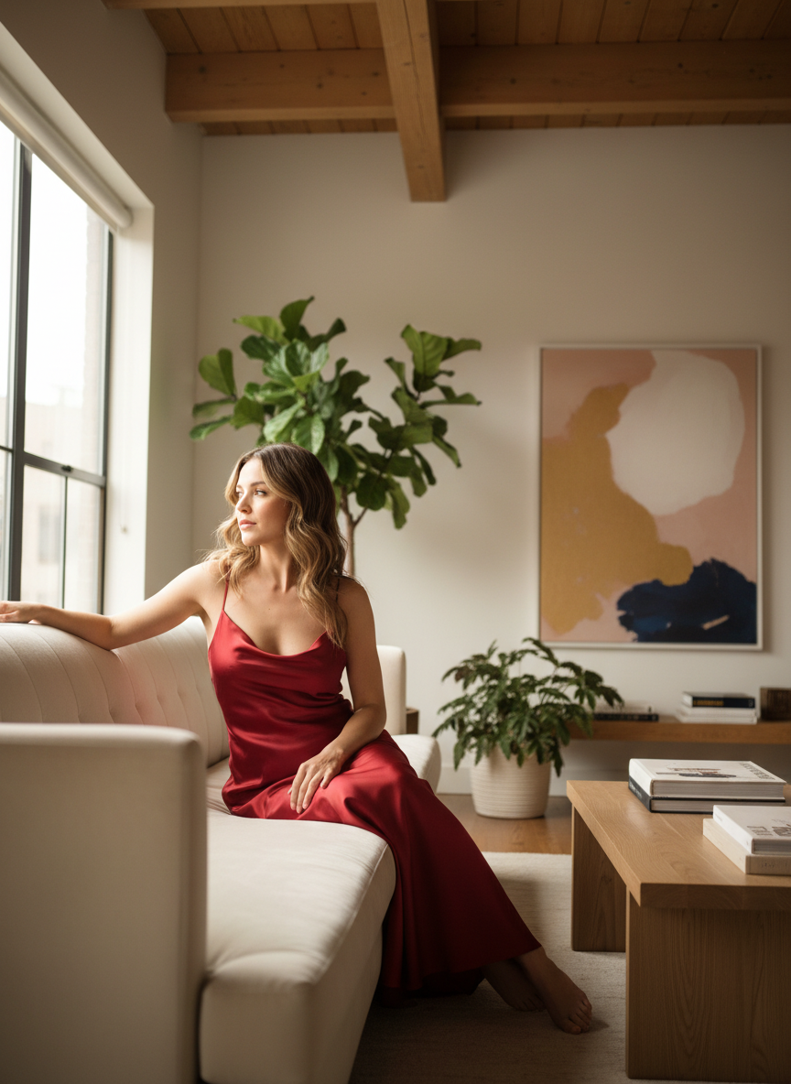

A red silk slip dress is the ultimate classic for a romantic night out. The fabric catches the light perfectly and feels so luxurious against your skin. You can pair it with thin gold jewelry and some strappy heels to keep the look clean. It is simple but makes a massive impact as soon as you walk into the room.

# Off The Shoulder Black Velvet Midi

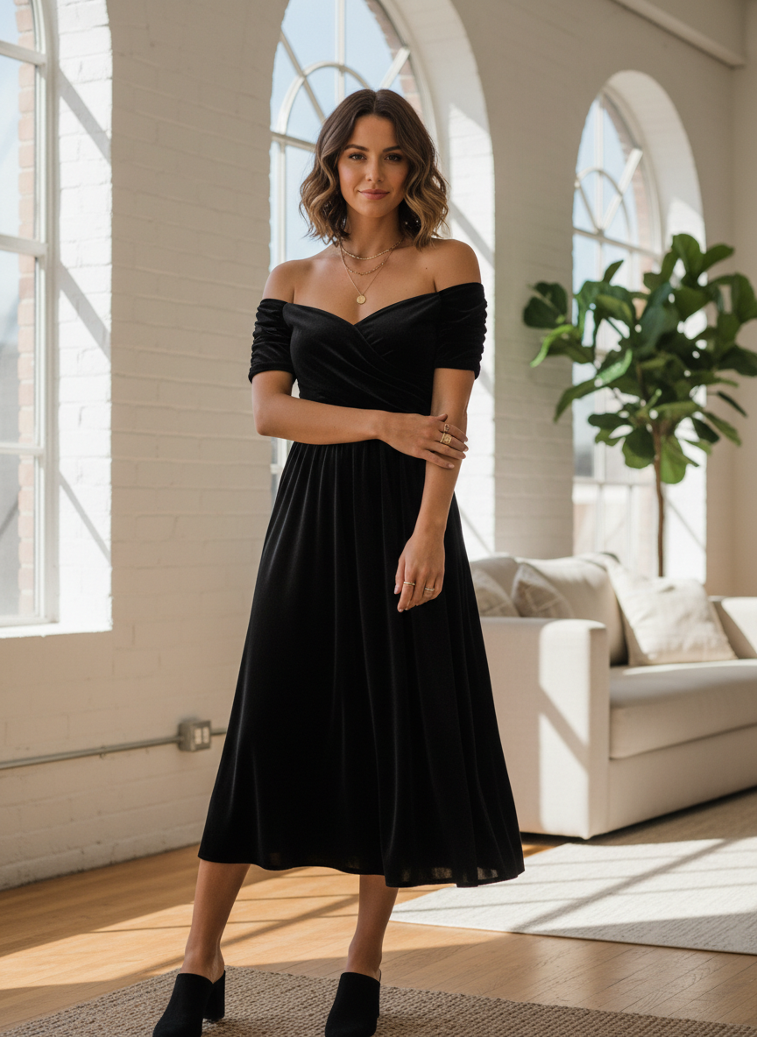

Black velvet is the definition of elegance for a winter date night. This dress hugs your curves in all the right places while the off the shoulder cut adds a little bit of spice. It looks amazing with a bold red lip and some sparkly earrings. This is the kind of outfit that never goes out of style and always looks expensive.

# White Oversized Blazer and Trousers

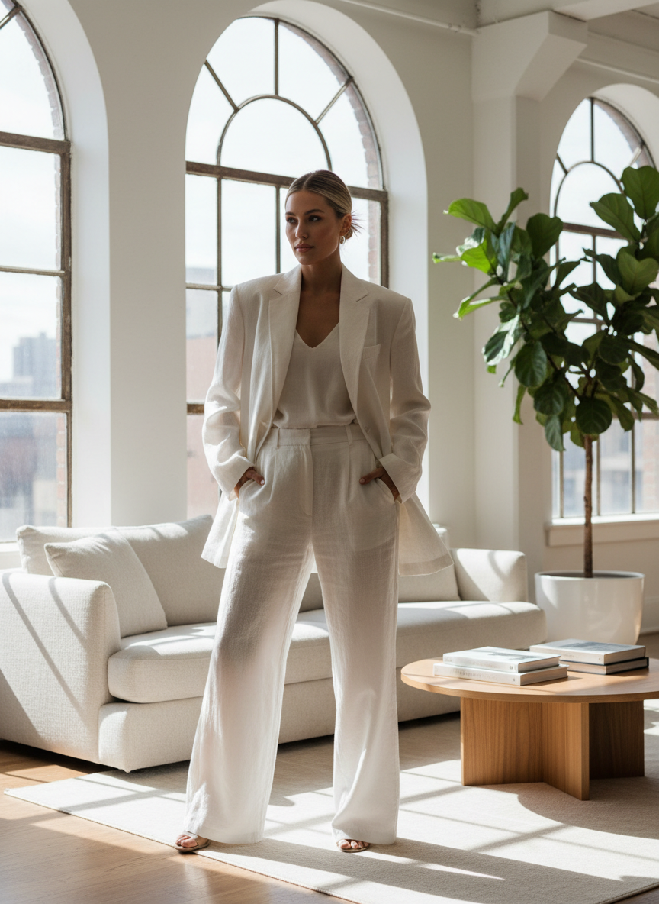

If you want to skip the dress, a crisp white suit is the way to go. This look is powerful and chic for a high end dinner setting. You can wear a lace bodysuit underneath to keep it feminine and cool. It shows that you have great taste. Finding 9 Classy Elegant Valentine’s Dinner Outfits That Aren’t Mid is easy when you use structured pieces like this.

# Satin Champagne Wrap Dress

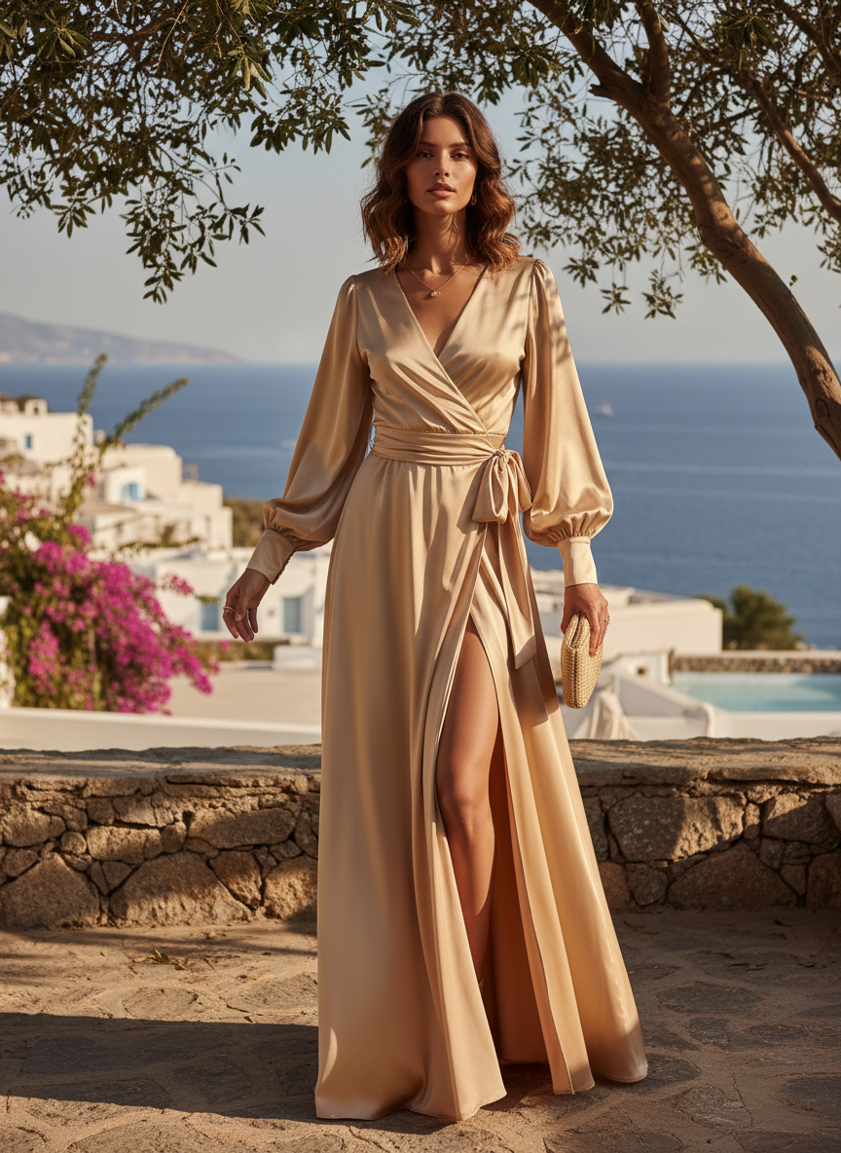

Satin champagne tones look so good under dim restaurant lighting. A wrap style is super flattering because it cinches your waist perfectly. The material gives off a glow that makes you look radiant all night long. Pair it with nude heels to lengthen your legs and keep the vibe sophisticated.

# Sheer Blouse with Leather Pants

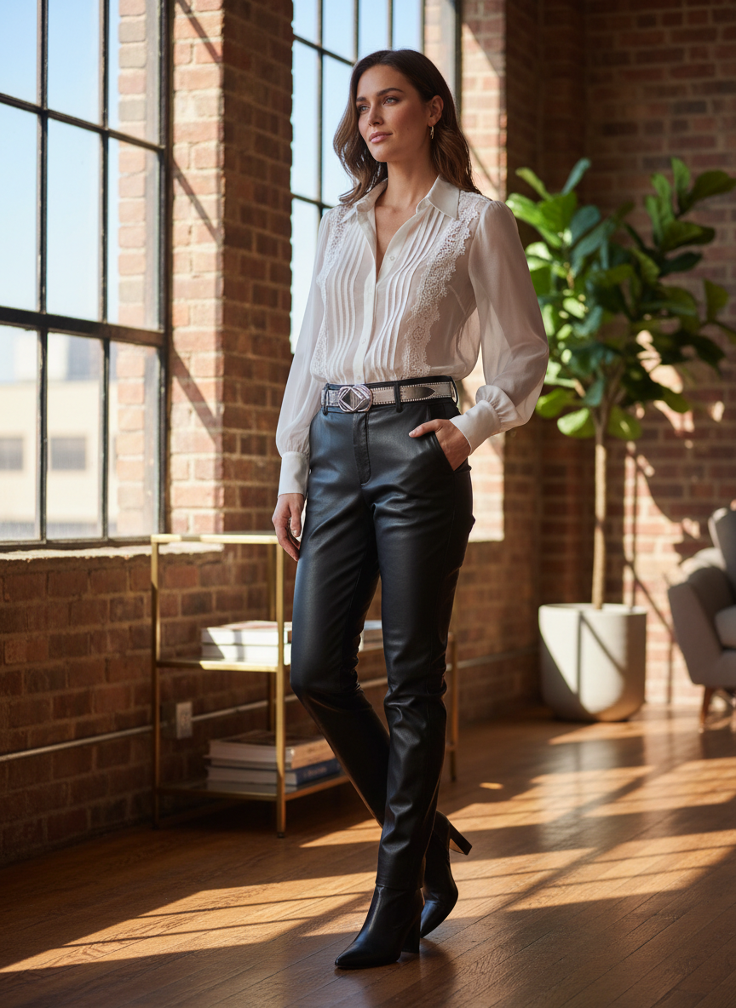

Mixing textures is a great way to make sure your outfit is not mid. A delicate sheer blouse looks so cool when you pair it with some sharp leather pants. This combo is edgy yet classy enough for a nice dinner. It is a perfect choice if you want to look a little bit more modern and trendy while staying elegant.

# Burgundy Bodycon with Slit

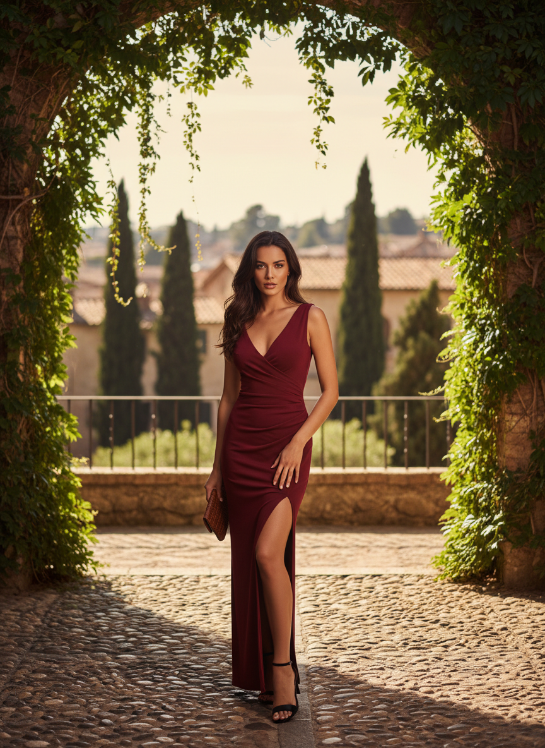

Burgundy is such a moody and romantic color for February. A long sleeve bodycon dress with a high leg slit is a total showstopper. It keeps you warm but still lets you show a little bit of skin. Add some pointed toe boots or classic pumps to finish off this sleek look. These types of 9 Classy Elegant Valentine’s Dinner Outfits That Aren’t Mid will always get you compliments.

# Pink Tweed Set

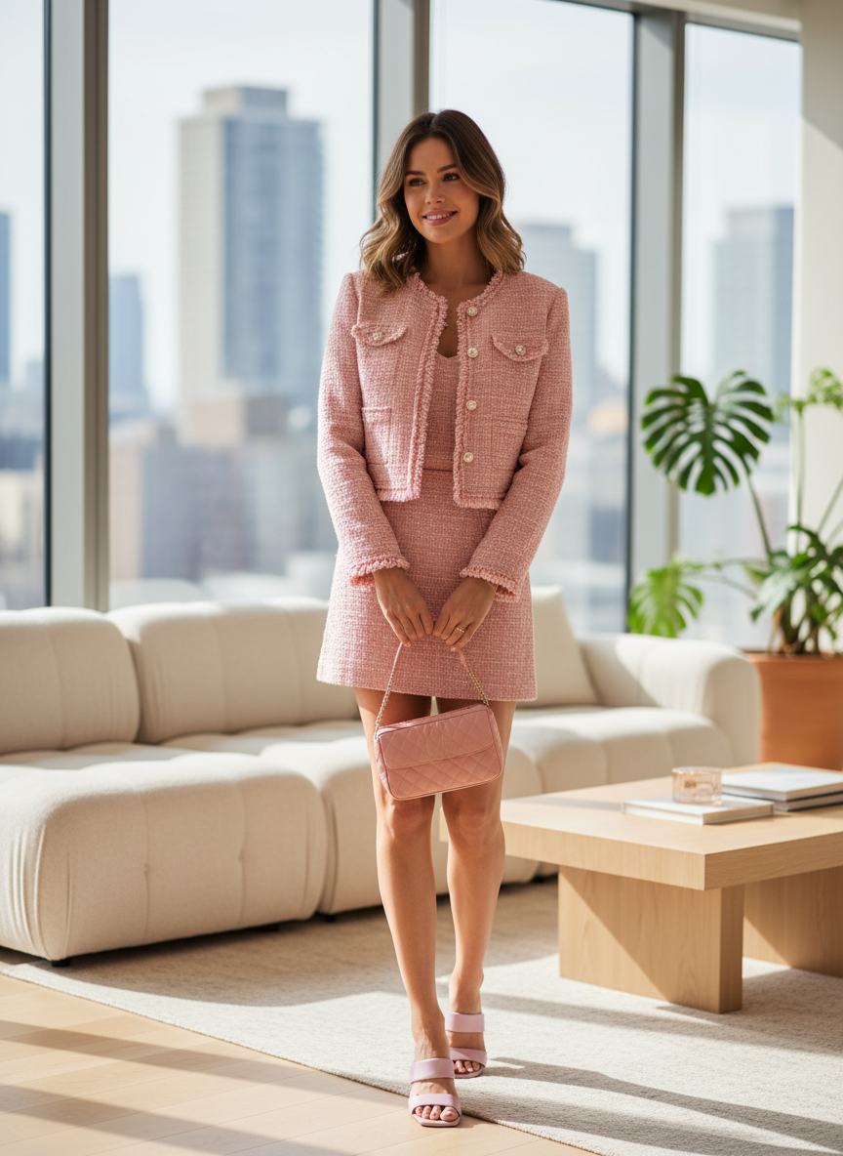

A pink tweed set gives off total old money vibes for your dinner date. The matching jacket and skirt look very put together and high end. You can wear it with sheer tights and some loafers or heels. This is a great option if you want to look sweet and polished at the same time.

# Cream Sweater and Sequin Skirt

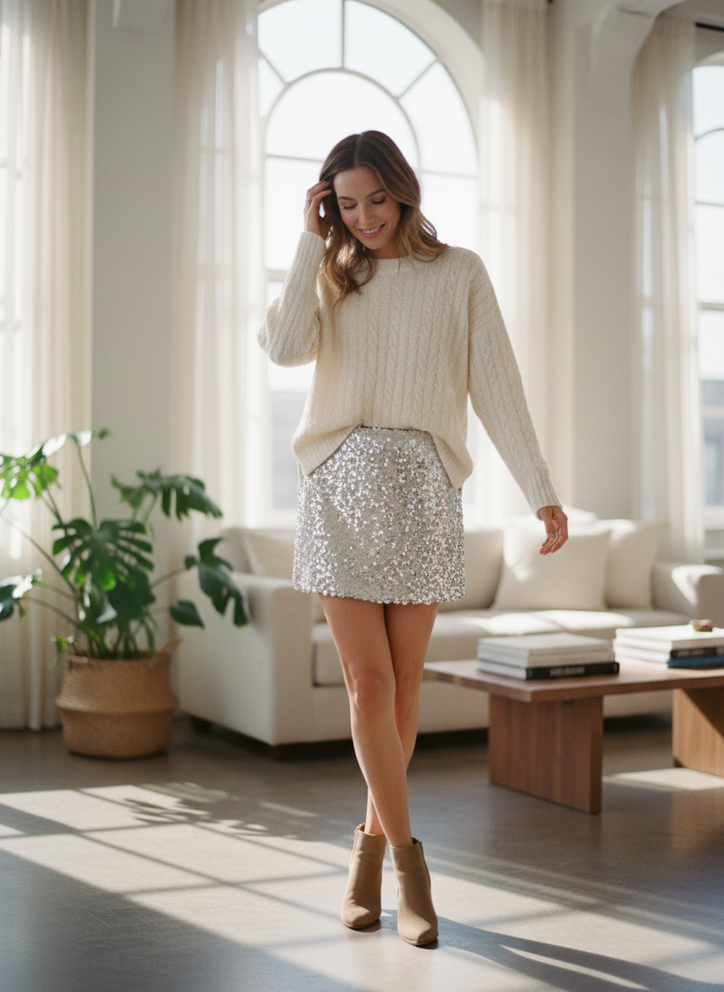

You can definitely wear sequins for Valentine’s Day without looking like a disco ball. A cream knit sweater balances out a flashy sequin midi skirt perfectly. It creates a cozy yet glam look that is perfect for a fancy meal. This outfit is all about being comfortable while still looking like you put in a lot of effort.

# High Neck Lace Mini

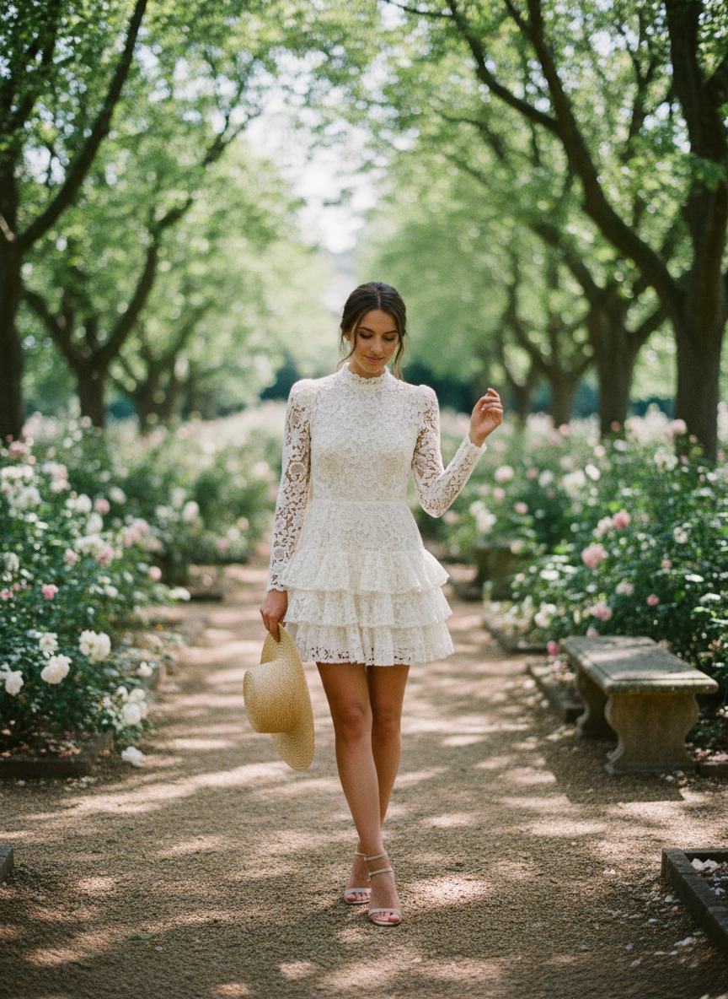

Lace is a timeless fabric that always feels romantic. A high neck mini dress in a dark color like navy or forest green is so chic. It is a great way to show off your legs while keeping the top part of the look very modest and refined. Wear it with some statement earrings to draw attention to your face.

# Conclusion

Picking the right look for your date night is the best way to start the evening. These outfits ensure you look classy and feel amazing without following the same old trends. You will definitely be the best dressed person in the restaurant. Pick your favorite style and own the night. Save these ideas to Pinterest now.